**Фоменко Екатерина**

**Лабораторная работа 1 сделана в паре с Картавщиковой Юлей, отдельно загружена в репозиторий “** [Laboratornie](https://github.com/bahterina/Laboratornie)**”**

**Лабораторная работа 3.**

**Задание 3.**

select th_surename, th_name, th_midlename, count(m_value)

from teach th join mark m on th_num = m_tnum

where m_snum in

{

select m_snum

from mark m

group by (m_snum)

having avg(m_value) < 4

}

and m_value = 2

group by th_surename, th_name, th_midlename

**Задание 2.**

вариант 1

select st_surename, st_name, st_midlename, count(m_value)

from student st join mark m on st_num in

{

select m_snum

from mark m

group by (m_snum)

having (m_value) <>2

}

вариант 2

select S.s_Surename, S.s_Name,S.s_Midlename

from Stud S

where not exists

(

select *

from mark m

where m.m_value = 2 and s.s_num = m.m_snum

)

group by s.s_surename, s.s_name,s.s_midlename

**Задание 1.**

select count(m_snum)

from mark m

where m_tnum in

{

select m_tnum

from mark m

where m_value = 2

group by m_tnum

order by count(m_tnum) desc

}

and m_value = 5

**Лабораторная работа 2**

**1.**

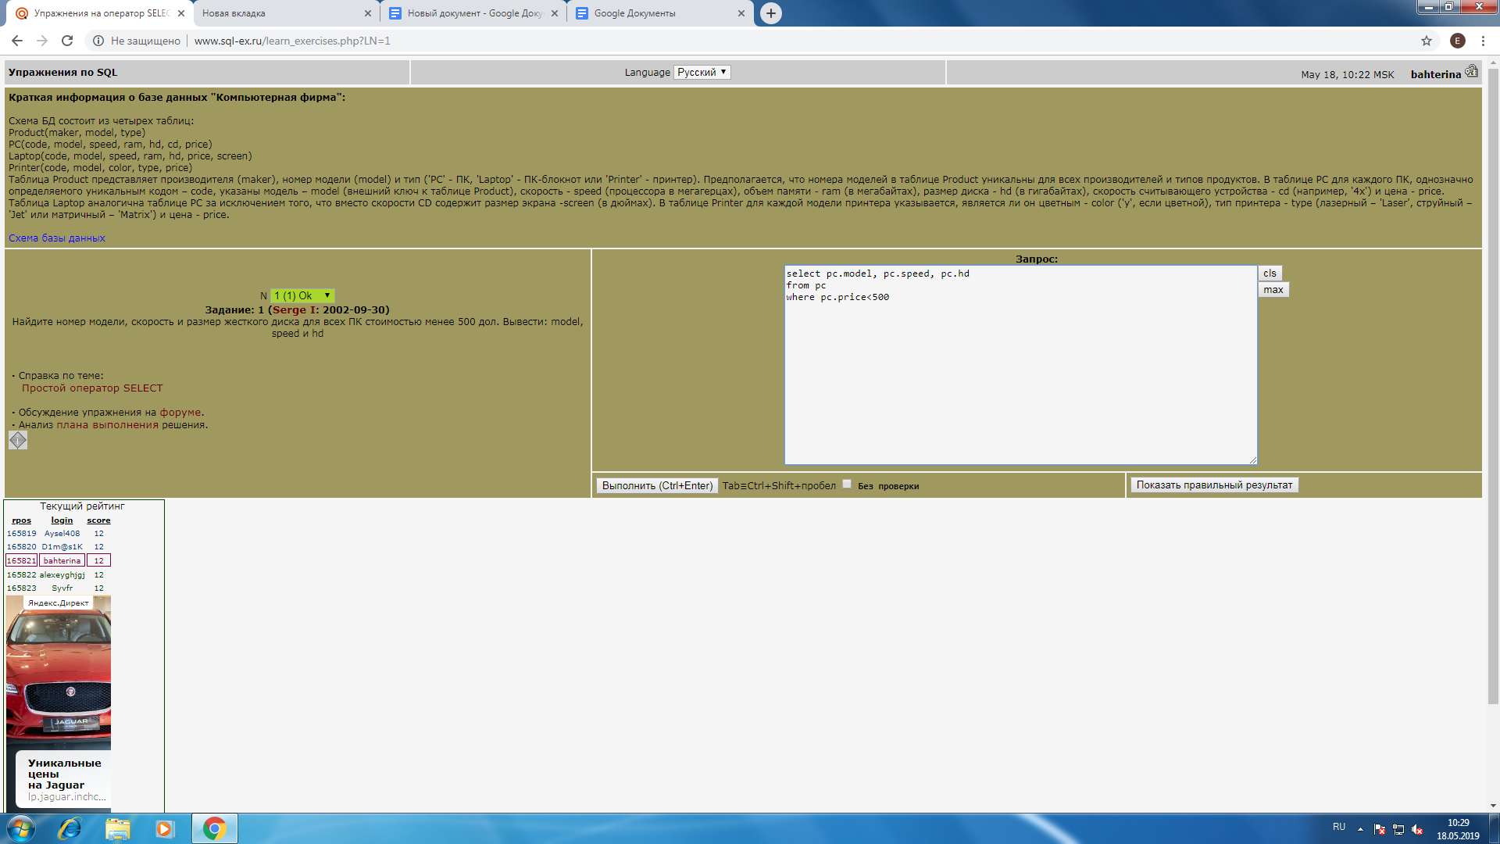

**2.**

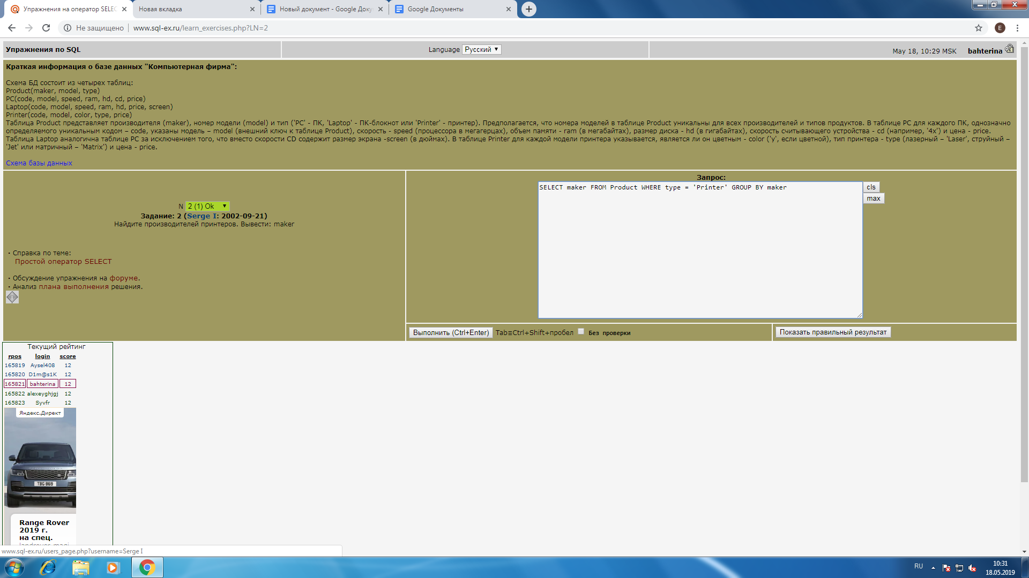

**3.**

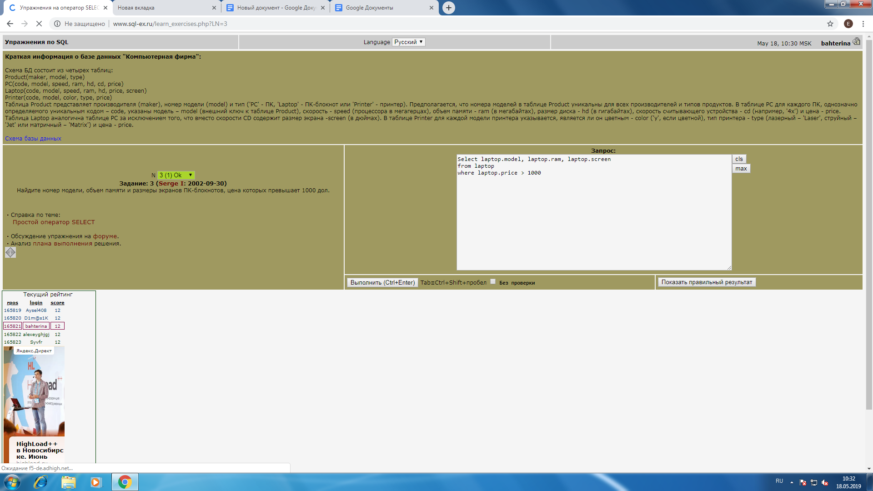

**4.**

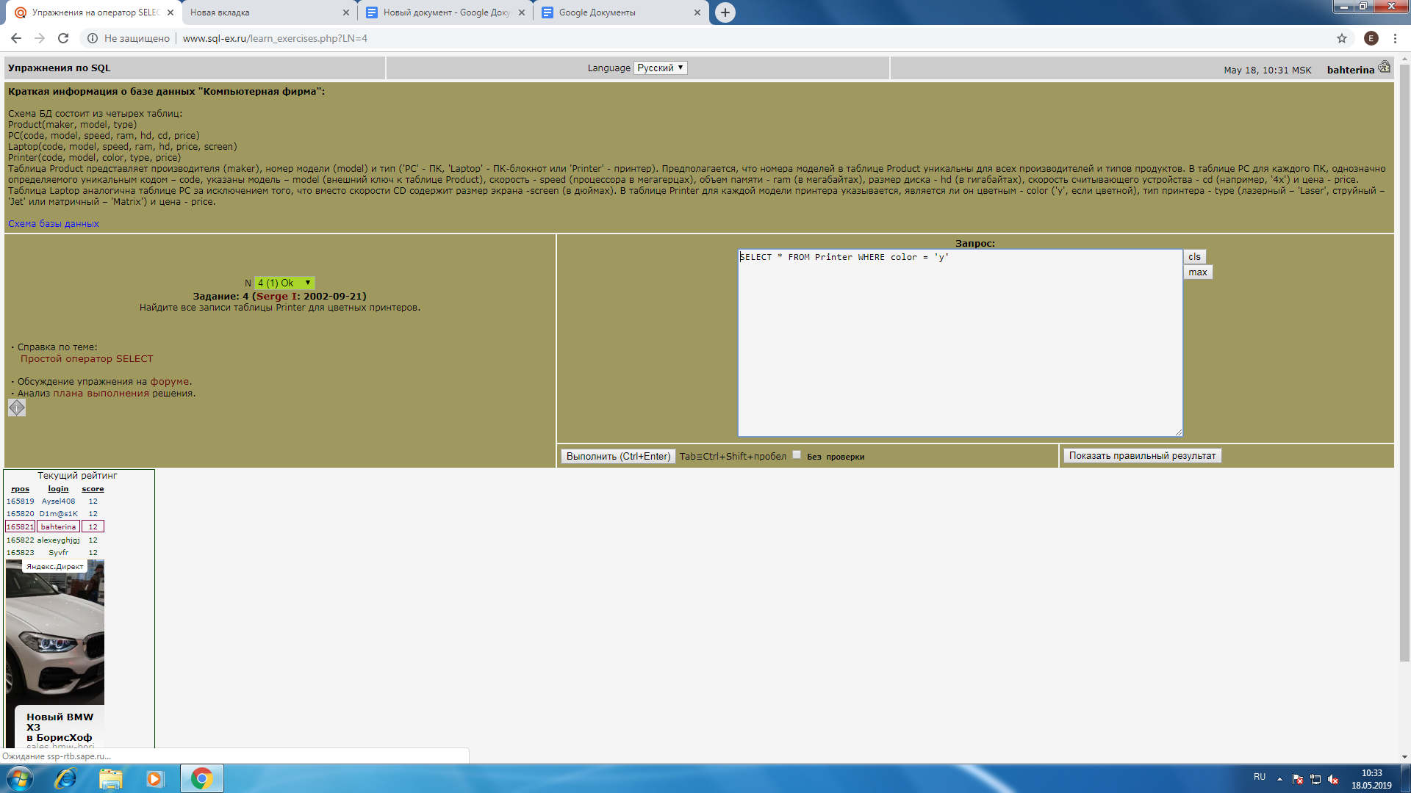

**5.**

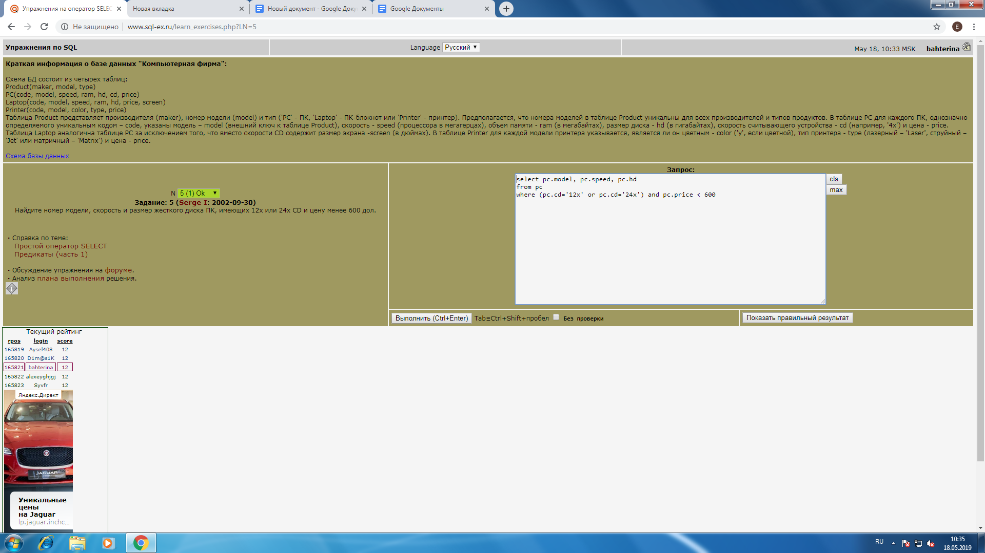

**6.**

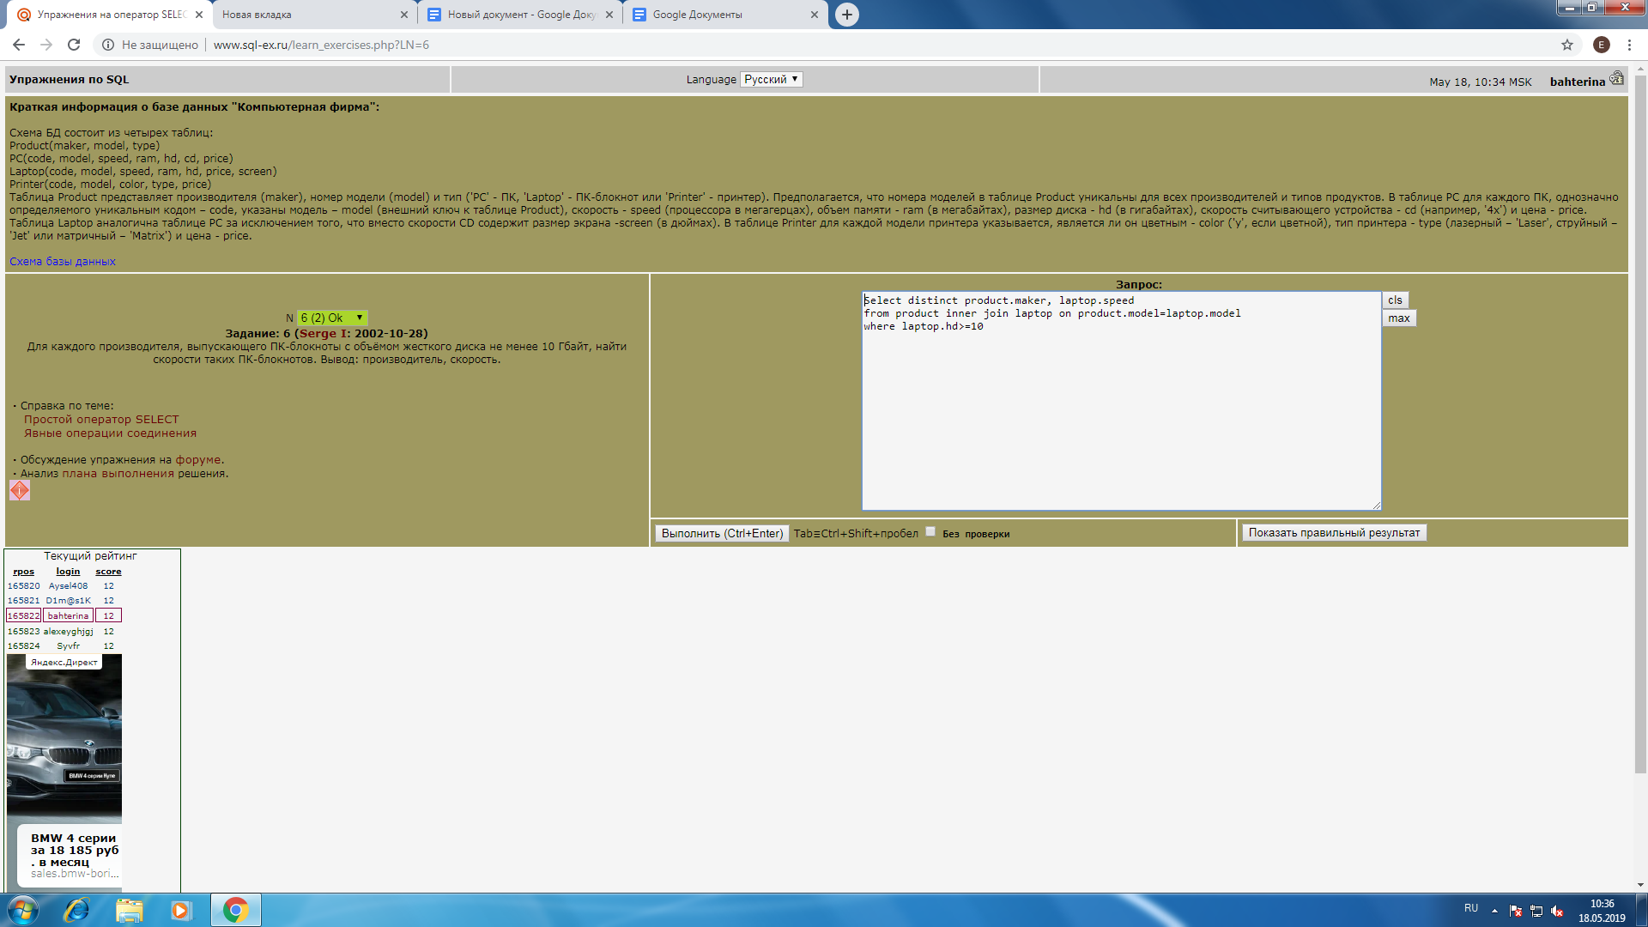

**9.**

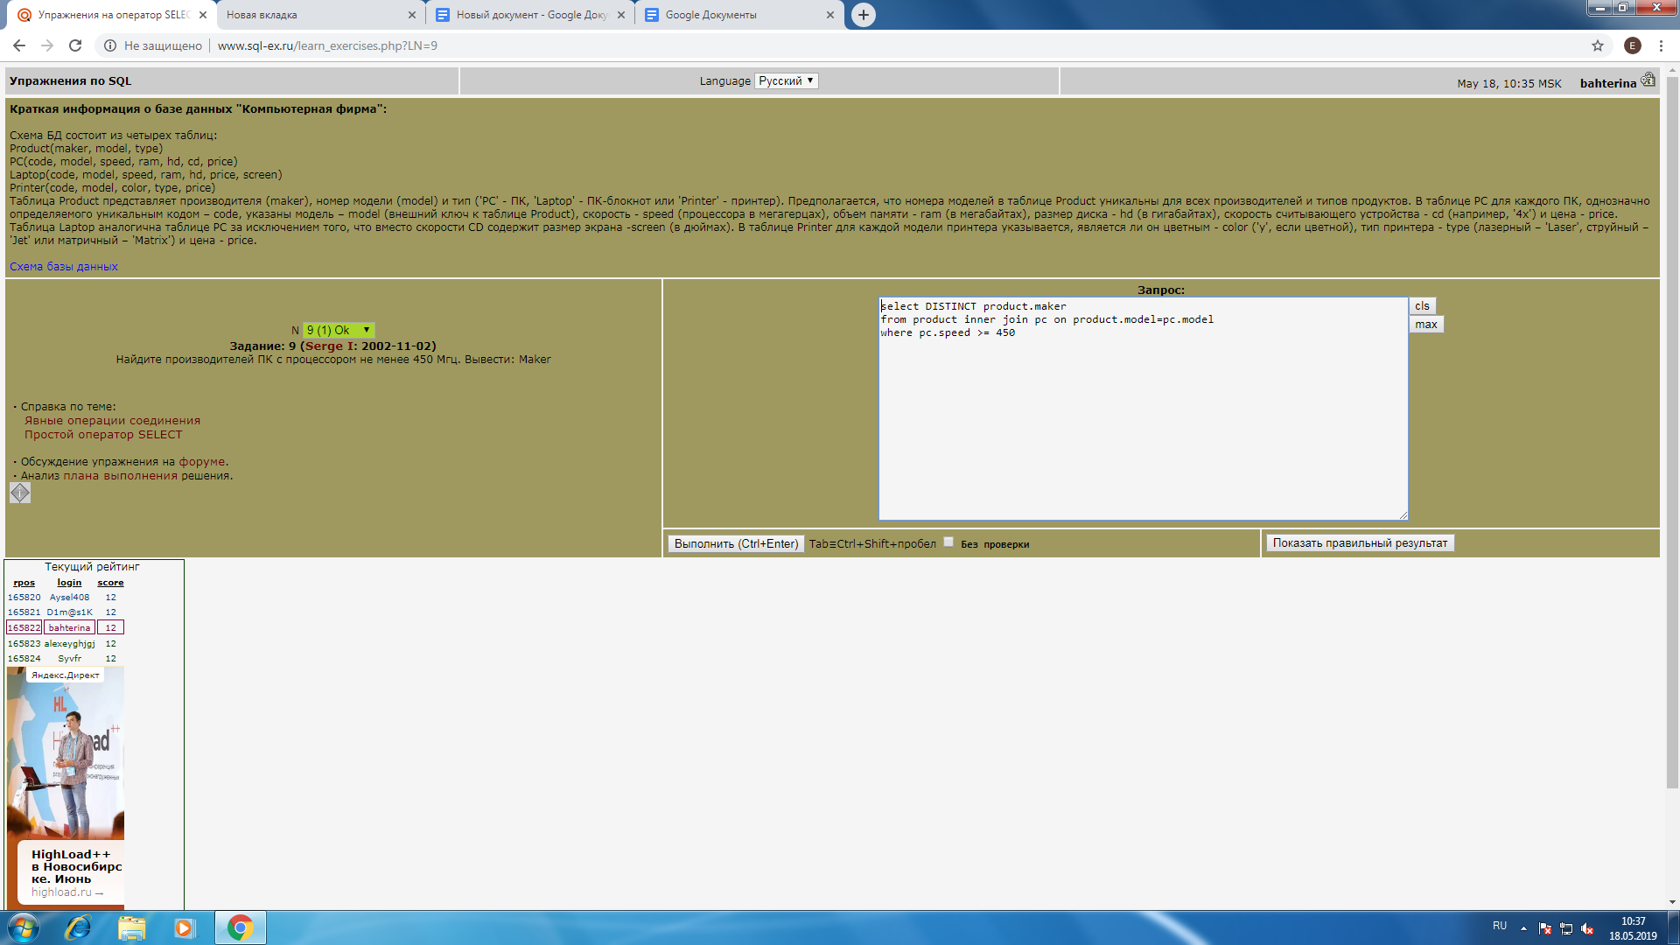

**18.**

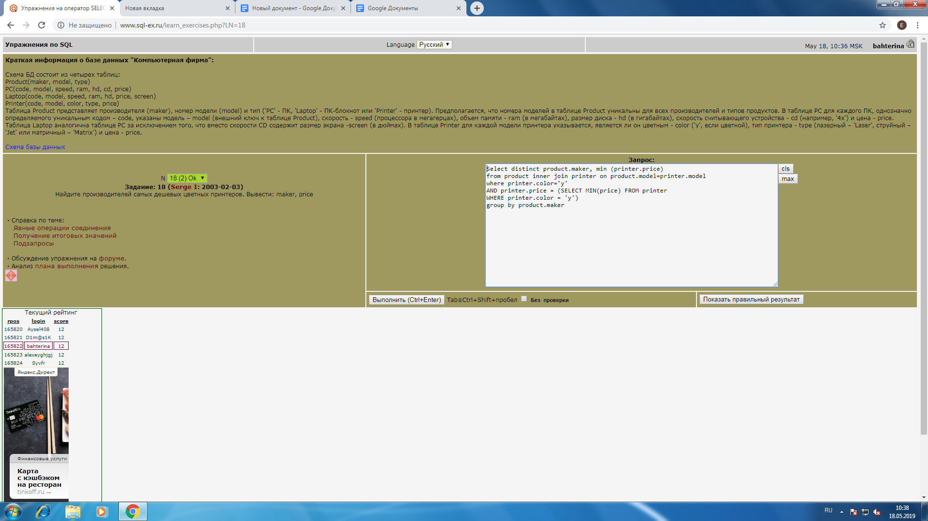

**35.**

